Exploring the Carbon Cycle with Data

A deeper understanding of the carbon cycle can be gained by analyzing real world datasets. This data interactive focuses on four case studies on time scales ranging from hours to hundreds of thousands of years. Many of these datasets have provided critical insights into our understanding of the carbon cycle.

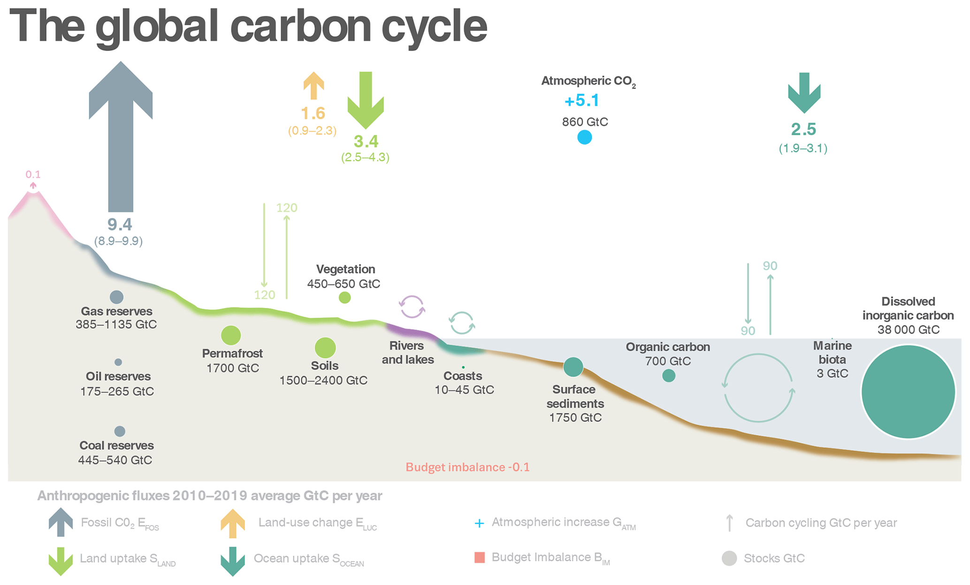

In terms of definitions, a carbon reservoir stores carbon and is measured in gigatons of carbon (GtC) where one gigaton is roughly equal to the mass of 200 million elephants. Some of the most important carbon reservoirs includes the ocean, soils, vegetation, fossil fuel reserves, and the atmosphere. Carbon fluxes refer to the amount of carbon that gets exchanged between reservoirs per year.

Prior to 1750, the carbon cycle was largely balanced. On land, photosynthesis captured 120 GtC of carbon from the atmosphere each year while respiration by plants, animals, and decomposers released 120 GtC back into the atmosphere each year. Similarly, the oceans absorbed around 90 GtC of each year and released 90 GtC back to the atmosphere each year.

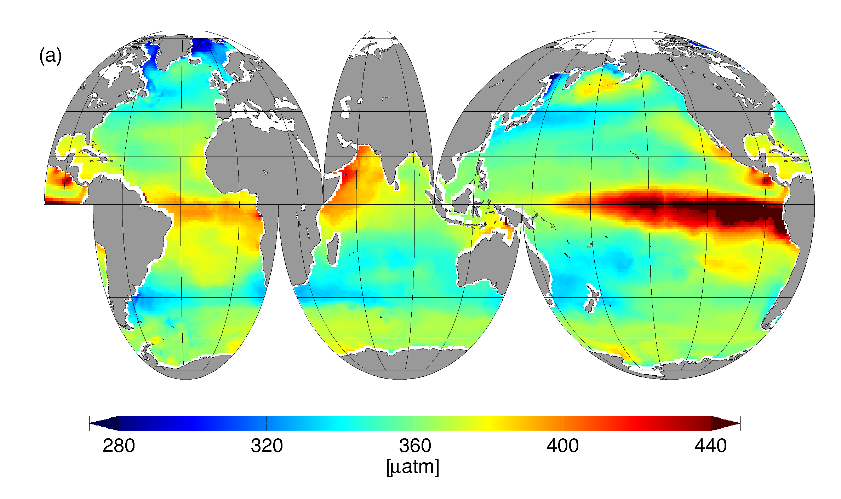

The cartoon above shows the surface pCO2 values. The red regions represent locations where deep carbon-rich water upwells to the surface, releasing carbon back into the atmosphere. The blue regions represent regions where phytoplankton photosynthesis deplete surface ocean dissolved inorganic carbon concentrations, resulting in the flux of carbon from the atmosphere into the ocean.

Humans have perturbed the carbon cycle. The flux of carbon from the land to the atmosphere has increased from fossil fuel combustion and through land use change such as deforestation. This increase in atmospheric carbon dioxide concentrations has caused the greening of the earth (higher photosynthesis rates on land). In addition, higher atmospheric carbon dioxide concentrations have increased the flux of carbon from the atmosphere into the ocean, resulting in ocean acidification.

The atmosphere interactive examines atmospheric CO2 concentrations from eleven locations around the globe to examine interannual variability and human impacts. The coral reefs interactive examines CO2 concentrations in the water column above a shallow coral reef to examine diurnal variability. The ocean interactive highlights changes in CO2 concentrations and pH over the last few decades at three open ocean locations. Finally, the ice cores interactive examines changes in atmospheric CO2 concentrations over hundreds of thousands of years.

   <!--close navbar-->

    /\* navigation \*/

    nav {

    font-weight:600;

    font-size:1.25em;

    background-color: rgba(255,255,255, 0.9);

    }

    .nav li{

    padding-right:5px;

}

    <!-- Navigation Bar -->

    <nav class="navbar navbar-expand-md navbar-light fixed-top">

        <!-- Button in navbar with collapse -->

        <button class="navbar-toggler" type="button" data-toggle="collapse" data-target="#navbarCollapse">

            <span class="navbar-toggler-icon"></span>

        </button>

        <!-- NavBar -->

        <div class="collapse navbar-collapse" id="navbarCollapse">

            <ul class="navbar-nav ml-auto mr-auto">

                <li class="navbar-item">

                    <a href="#about" class="nav-link">ABOUT</a>

                </li>

                <li class="navbar-item">

                    <a href="#skills" class="nav-link">SKILLS</a>

                </li>

                <li class="navbar-item">

                    <a href="#projects" class="nav-link">PROJECTS</a>

                </li>

                <li class="navbar-item">

                    <a href="#research" class="nav-link">RESEARCH</a>

                </li>

                <li class="navbar-item">

                    <a href="#adventures" class="nav-link">ADVENTURES</a>

                </li>

            </ul>

        </div>

    </nav>

  <!-- Bootstrap CSS -->

        <link rel="stylesheet" href="https://stackpath.bootstrapcdn.com/bootstrap/4.4.1/css/bootstrap.min.css" integrity="sha384-Vkoo8x4CGsO3+Hhxv8T/Q5PaXtkKtu6ug5TOeNV6gBiFeWPGFN9MuhOf23Q9Ifjh" crossorigin="anonymous">